BULL CREEK PRIMARY SCHOOL

Annual Report 2021







**Table of Contents**

**Contents**

**Cover Page……………………………………………………………………………. 1**

**Table of Contents……………………………………………………………………. 2**

**School Overview ……………………………………………………………………. 3**

**Student Numbers ……………………………………………………………………. 4**

**Attendance……………………………………………………………………………. 5**

**NAPLAN – Numeracy………………………………………………………………. 6**

**NAPLAN – Reading………………………………………………………………… 7**

**NAPLAN – Writing……………………………………………………………………. 8**

**Destination Schools…………………………………………………………………. 9**

**National School Opinion Survey…………………………………………………… 10**

**Financial Summary…………………………………………………………………… 11**

**School Priorities………………………………………………………………………. 12**

**School Board Chair Report…………………………………………………………. 13 - 14**

**P&C President Report ………………………………………………………………. 15 – 17**

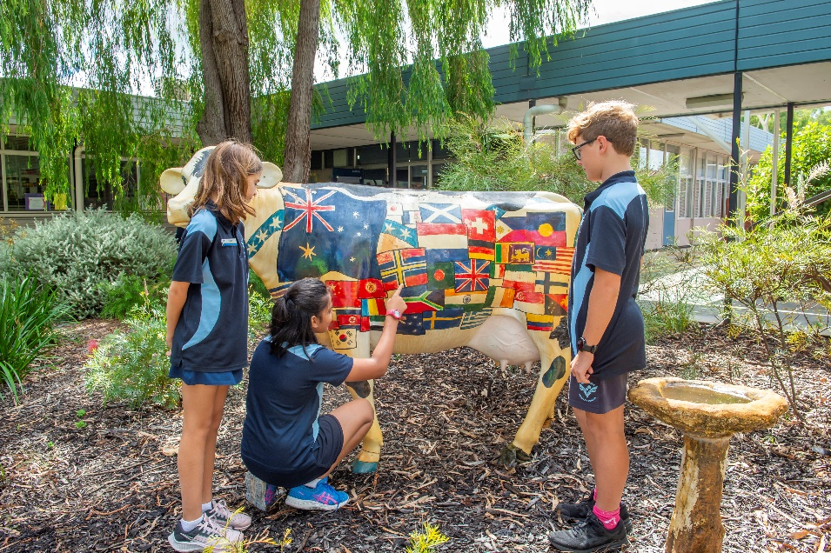

**Bull Creek Primary School Annual Report**

Bull Creek Primary School became an Independent Public School in 2014. The school provides high quality teaching and learning via delivery of evidence-based programs. Staff have high expectations and embrace strong pastoral care upholding the school’s values and vision.

Our school is recognised for developing and building strong relationships and community engagement. The School Board and Parent & Citizens are paramount in connecting the school, home and community.

Bull Creek Primary School students are from diverse ethnic backgrounds and they interact harmoniously in an environment that encourages academic achievement, social and emotional wellbeing and resilience.

The professional ethos and collaborative practices in the school ensures teacher accountability for student development, classroom initiatives and curriculum implementation. Our staff are experienced, professional and implement effective use of ICT to support and enhance learning.

The ***Bull Creek Way*** document was produced in consultation with the School Board, the staff and students and describes our expectations for all to follow whilst at Bull Creek Primary School.

It defines the responsibilities that all members of the school community are expected to uphold and recognises the significance of appropriate and meaningful relationships.

The Bull Creek Way is underpinned by the following principles:

* Bull Creek Primary school is committed to providing all students a safe, supportive and disciplined learning environment.
* Bull Creek Primary School expects high standards of personal achievement and behaviour.
* Partnerships with parents, the wider community and other support agencies contribute to positive outcomes in our school.
* Staff expertise is valued and developed.
* Responses to inappropriate student behaviour must consider both the individual circumstances and actions of the student and the needs and rights of the school community.

**EAL/D**

Bull Creek Primary School is a culturally diverse community with over 40 languages spoken by our students. We recognise this wonderfully rich cultural and linguistic diversity and take every opportunity to acknowledge and celebrate this through parent engagement.

Bull Creek Primary School has a comprehensive English program catering for students from Pre-Primary to Year 6, with a focus on oral and written competence in Standard Australian English. The English as an Additional Language or Dialect (EAL/D) staff implement and support programs, working in collaboration with classroom teachers.

We also support parents, enabling them to fully engage in their child’s education in their school community by facilitating workshops to assist with learning at home. The “Culture Friendship Club” is a place where parents can connect and network with each other and the broader school community.

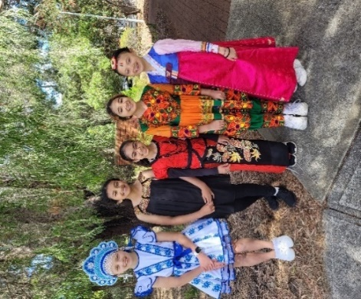 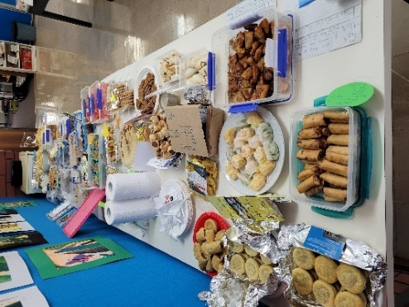 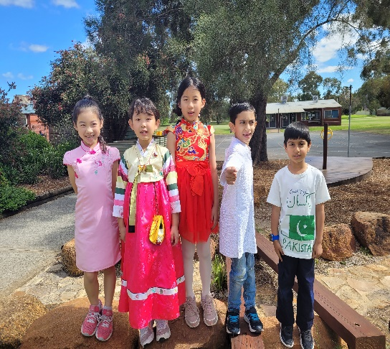

**Student Numbers and Characteristics** Student Numbers (as at 2021 Semester 2)

|  |  |  |  |  |  |  |  |  |  |
| --- | --- | --- | --- | --- | --- | --- | --- | --- | --- |
| **Primary** | **Kin** | **PPR** | **Y01** | **Y02** | **Y03** | **Y04** | **Y05** | **Y06** | **Total** |
| Full Time | (19) | 43 | 39 | 52 | 47 | 58 | 68 | 75 | 401 |
| Part Time | 31 |  |  |  |  |  |  |  |  |

Note: The Kin Full Time student figure represents the Full Time Equivalent of the Part Time students

|  |  |  |  |  |  |
| --- | --- | --- | --- | --- | --- |
|  | **Kin** | **PPR** | **Pri** | **Sec** | **Total** |
| Male | 19 | 16 | 164 |  | 199 |
| Female | 12 | 27 | 175 |  | 214 |
| Total | 31 | 43 | 339 |  | 413 |

In 2021 there was an increase in student numbers and new families moving into the local area. There is, however, a decrease in Kindy and Pre-Primary enrolment numbers which will impact the future population of the school.

**Workforce Composition - Staff Information**

|  | **No** | **FTE** | **AB'L** |
| --- | --- | --- | --- |
|  | | |  |
| **Administration Staff** |  |  |  |
| Principals | 1 | 1.0 | 0 |
| Associate / Deputy / Vice Principals | 2 | 2.0 | 0 |
| Total Administration Staff | 3 | 3.0 | 0 |
|  | | |  |
| **Teaching Staff** |  |  |  |
| Level 3 Teachers | 2 | 0.9 | 0 |
| Other Teaching Staff | 23 | 18.4 | 0 |
| Total Teaching Staff | 25 | 19.3 | 0 |
|  | | |  |
| **School Support Staff** |  |  |  |
| Clerical / Administrative | 4 | 2.6 | 0 |
| Gardening / Maintenance | 1 | 0.6 | 0 |
| Other Non-Teaching Staff | 10 | 6.6 | 0 |
| Total School Support Staff | 15 | 9.8 | 0 |
|  | | | |
| **Total** | **43** | **32.1** | **0** |

Bull Creek Primary has a very stable workforce with many of the staff working at the school for long periods of time.

This year saw an increase in the number of graduate teachers on the staff, an increase in Special Needs Education Assistants and the employment of a School Chaplain.

**Student Attendance**

Bull Creek Primary School continues to present higher attendance rates than the state average. With international borders closed there were less families travelling overseas during the school calendar year, helping to increase 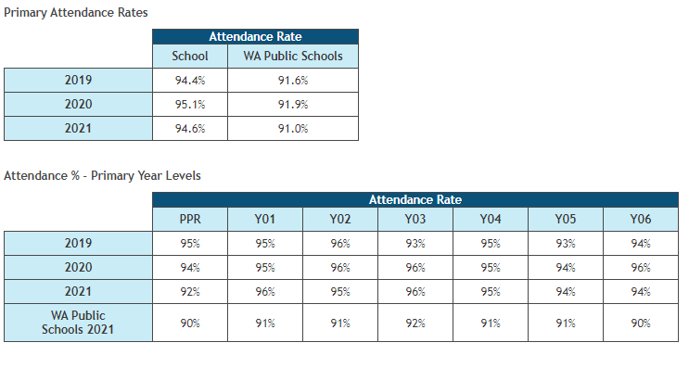overall attendance rates. Non- attendance is followed up with phone calls and written letters to families. Reminders about the importance of regular attendance are placed in the school newsletters. Support is offered to those families having difficulty in getting their children to school.

**Student Achievement and Progress**

**Numeracy**

**Percentages of students Above, At, and Below National Minimum Standard Levels**

| **NAPLAN National Minimum Standard (NMS)** | **NAPLAN - Numeracy** | | | | | | | | |
| --- | --- | --- | --- | --- | --- | --- | --- | --- | --- |
| **2018** | | | **2019** | | | **2021** | | |
| **Year 3** | **Year 5** | **Year 7** | **Year 3** | **Year 5** | **Year 7** | **Year 3** | **Year 5** | **Year 7** |
| **Above NMS** | **92%** | **90%** |  | **100%** | **91%** |  | **91%** | **97%** |  |
| **At NMS** | **5%** | **10%** |  | **0%** | **9%** |  | **9%** | **3%** |  |
| **Below NMS** | **3%** | **0%** |  | **0%** | **0%** |  | **0%** | **0%** |  |

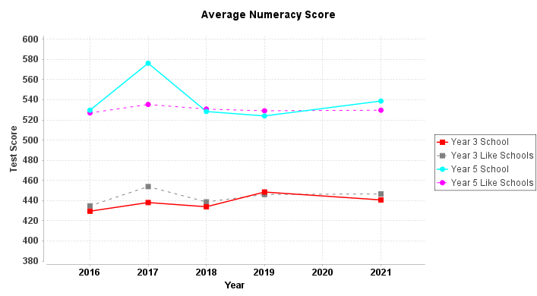

Numeracy results once again reflect no students below the National Minimum Standard. Year 3 results are slightly below but comparable with like schools. The Year 5 results in Numeracy are higher than those of like schools with a steady incline over the past two years. Students whose achievement was At NMS have been targeted to receive additional support to help improve their understanding and performance. Following thorough interrogation of results, staff also identified students who would benefit from extension programs.



**Reading**

**School compared to National Minimum Standard**

| **NAPLAN National Minimum Standard (NMS)** | **NAPLAN - Reading** | | | | | | | | |
| --- | --- | --- | --- | --- | --- | --- | --- | --- | --- |
| **2018** | | | **2019** | | | **2021** | | |
| **Year 3** | **Year 5** | **Year 7** | **Year 3** | **Year 5** | **Year 7** | **Year 3** | **Year 5** | **Year 7** |
| **Above NMS** | 97% | 88% |  | 96% | 97% |  | 98% | 98% |  |
| **At NMS** | 3% | 12% |  | 4% | 3% |  | 2% | 2% |  |
| **Below NMS** | 0% | 0% |  | 0% | 0% |  | 0% | 0% |  |

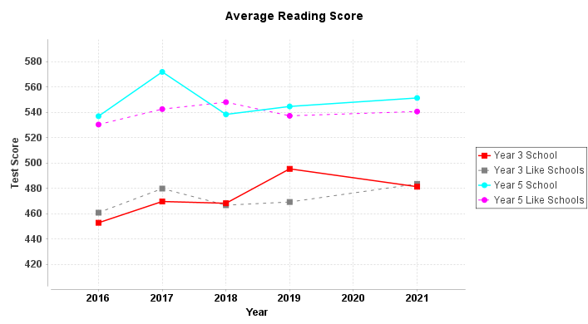

The Year 5 results indicate that Bull Creek Primary School students were above like schools in Reading. We had a very high percentage of students achieving above the NMS in both Year 3 and Year 5. The Year 3 results were comparable to like schools. The students who were At NMS have been identified and intervention programs initiated. With the high number of students achieving above the NMS, staff agreed that “adding value” to these students should be a priority.

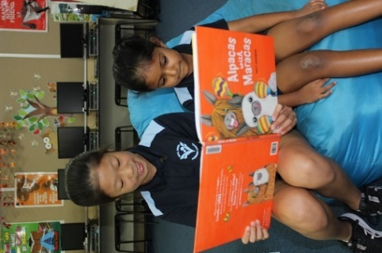

**Writing**

| **NAPLAN National Minimum Standard (NMS)** | **NAPLAN - Writing** | | | | | | | | |
| --- | --- | --- | --- | --- | --- | --- | --- | --- | --- |
| **2018** | | | **2019** | | | **2021** | | |
| **Year 3** | **Year 5** | **Year 7** | **Year 3** | **Year 5** | **Year 7** | **Year 3** | **Year 5** | **Year 7** |
| **Above NMS** | 95% | 95% |  | 100% | 94% |  | 100% | 94% |  |
| **At NMS** | 2% | 2% |  | 0% | 6% |  | 0% | 3% |  |
| **Below NMS** | 3% | 2% |  | 0% | 0% |  | 0% | 3% |  |

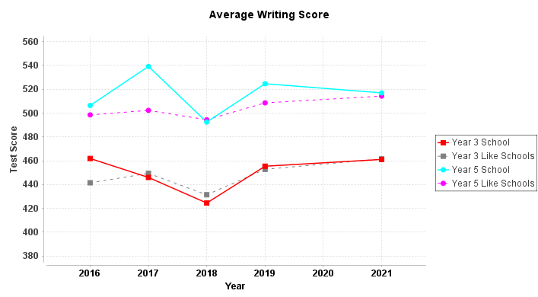

In Writing the school data reflects the trends displayed by like schools and the results are comparable. The Year 3 longitudinal trend for Writing is consistent with like schools. There are, however, a small percentage of students in Year 5 who are At or Below the National Minimum Standard. This hasn’t occurred since 2018 and can be partly contributed to the changing demographics in the local area and increased enrolments in middle and senior primary. These students have been identified and additional supports implemented. Whole school Writing strategies have been applied.



**Destination Schools**

**2021 school destinations of the 2020 student cohort**

|  |  |  |
| --- | --- | --- |
| **Year Level :** |  | Male: 20  Female: 17  Total: 37 |

|  |  |  |  |
| --- | --- | --- | --- |
| **Destination Schools** | **Male** | **Female** | **Total** |
| 4048 Rossmoyne Senior High School | 11 | 5 | 16 |
| 1396 Kennedy Baptist College | 4 | 1 | 5 |
| 4143 Leeming Senior High School | 2 | 3 | 5 |
| 4126 Willetton Senior High School |  | 4 | 4 |
| 4002 Applecross Senior High School |  | 1 | 1 |
| 1299 Corpus Christi College | 1 |  | 1 |
| 1470 Fountain College |  | 1 | 1 |
| 4198 Harrisdale Senior High School |  | 1 | 1 |
| 4113 Lynwood Senior High School | 1 |  | 1 |
| 1354 Mundaring Christian College | 1 |  | 1 |
| 1314 Providence Christian College | 1 |  | 1 |

In 2021 Year 6 students from Bull Creek Primary attended 11 different high schools. Transition programs for students are promoted and encouraged to enable a smooth transition to high school. This includes organised visits to Bull Creek Primary from staff and students from nearby high schools to help reduce anxiety associated with changing schools.

Many students apply for GATE programs at nearby school with a good percentage of children being successful in these applications.



**National School Opinion Survey Data**

**Staff Survey Results**

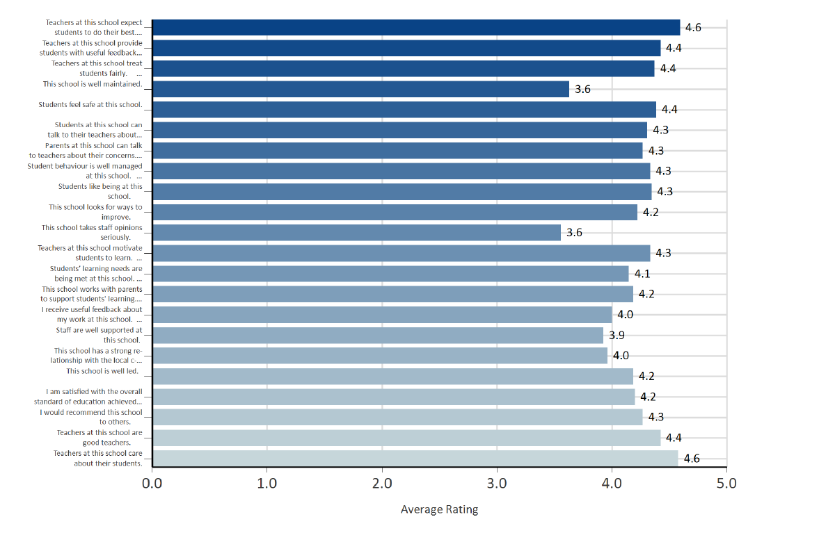

**Parent Survey Results**

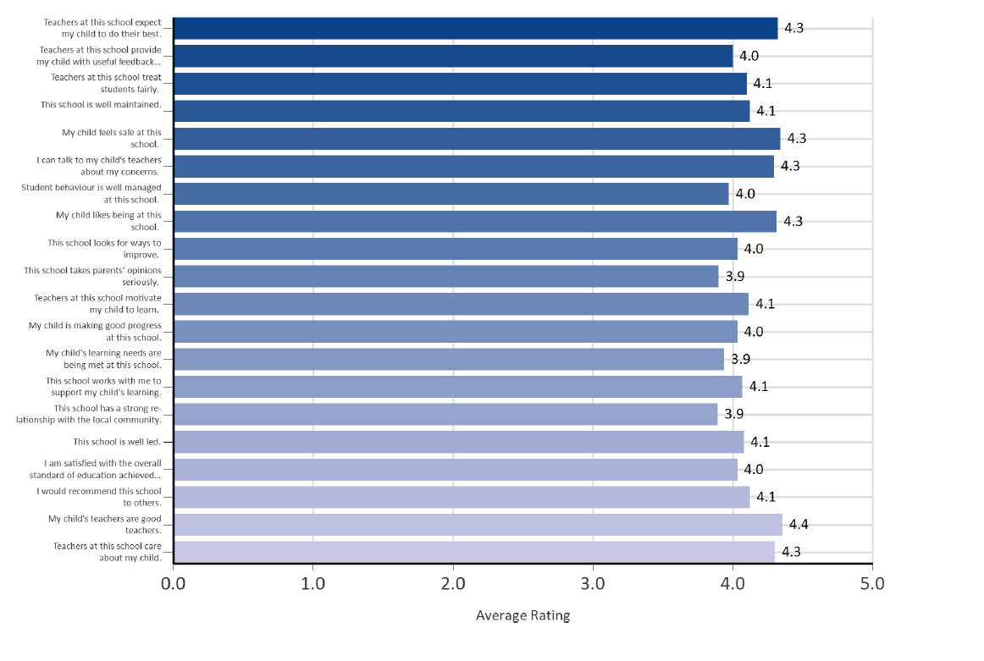

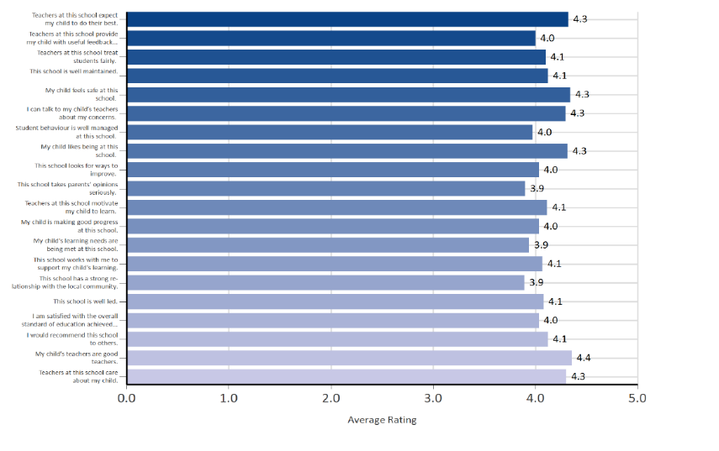**Student Survey Results**

This year 149 replies were received out of 260 families. This is a significant improvement on the 2018 survey where only 67 parents responded. This increased response from previous years and can be contributed to the school board members actively seeking parent participation in the survey.

The survey data was shared with staff and school board members who analysed and identified areas which received a rating below 4.0. These areas will be targeted for future improvement with proposed strategies.



**Identified School Priorities**

|  |  |  |
| --- | --- | --- |
| Identified school priority | Progress against priority | Planned actions |
| Increase the percentage of students with good and excellent achievement in NAPLAN Writing and Numeracy in the Year 3 and 5 stable cohort. | Targeted students in each class to be Case Managed in Literacy and Numeracy. | Whole school Writing focus on  improving vocabulary and sentence structure. |
| Maintain a strong focus in the early years and beyond on the explicit teaching of Literacy and Numeracy. | Implemented whole school approaches to Synthetic Phonics (Sounds Write) and Phonological Awareness (Heggerty) as essential skills for literacy.  All early K-PP received Professional Learning in these areas.  Continued to provide evidence-based intervention programs to assist students experiencing difficult.  Whole school approach to Numeracy.  All staff follow the Bull Creek Instructional Framework to ensure explicit teaching. | Provide Professional Learning for years 1-2 Teachers in Heggerty to ensure consistency of approach.  Expand the intervention programs to incorporate MaqLit. This includes building staff capacity in using the program. |
| Target skills in Digital Technologies across all year levels through the Bull Creek Scope and Sequence. | Purchased extensive new technology to be utilised throughout the school.  Implemented a Scope and Sequence for Digital Technology skills. | Employ a Digital Technology support teacher to build staff capacity. |
| Foster an inclusive environment supporting positive wellbeing and health for staff, students and community. | Introduction of whole school Mindfulness sessions.  Be You Professional Learning completed by staff.  Be You committee formed to support the implementation of whole community approach to mental health.  Introduction of OnPsych Psychology services within the school to support more families.  School Psychologist offering multiple Triple P Parenting seminars to parents. | Use survey data to direct focus for areas of need. |

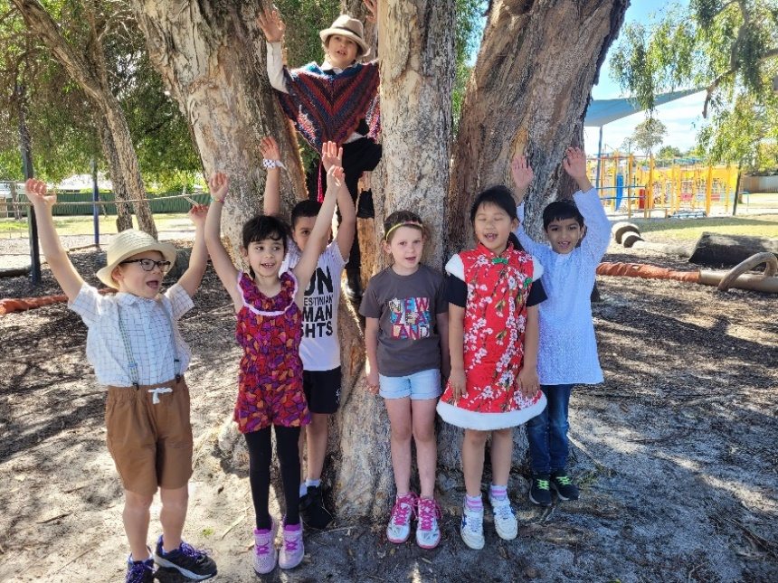

**2021 CHAIR REPORT – BULL CREEK PRIMARY SCHOOL BOARD**

This meeting, held once per year during Term 4, is open to the entire school community with the aim of presenting the Board’s Annual Report.

I would like to acknowledge Ms Martin who has retired post her leave for health reasons. We thank her for all her contributions to the school and wish her well with her health and retirement.

Additionally, I would like to acknowledge Ms Marchenko, who was appointed after the start of the year as principal for a fixed term for this school year. Ms Marchenko has entered the school with a great deal of energy and vigour and worked very hard on many items to improve the school and community, and the school community has not been more active or engaged in my eight years as part of the community.

**ROLE OF THE SCHOOL BOARD**

It is important to touch on the role of the Board in an Independent Public School. An overview of this role can be found on the Department of Education website and will likely be available on a soon to be upgraded school website. (www.education.wa.edu.au/dl/l9872k)

In summary, the board’s role is to work with the principal to determine the overall strategic directions of the school and the business plan, monitor the school’s performance and support the school to achieve its objectives.

**BULL CREEK PRIMARY SCHOOL BOARD**

Ideally, the Board is comprised of four Parents, four Community Members, four Staff and the Principal. Currently, the Board is comprised of:

|  |  |  |
| --- | --- | --- |
| **Parent Members** | **Community Members** | **Staff Members** |
| Sara Di Candilo | Rasa Subramanium | Sharon Marchenko (Principal) |
| Paige Goodsell | Matt Woodall | Brandon Ellis |
| Chris Hodson (term completed) |  | Amanda Allier |
| Darren Roberts |  | Julie McCarthy |
|  |  | Tracey Owen |

I note that in 2022 we will see a requirement for additions to the school board. We will be seeking at least two new members from the parent community and welcome any questions of anyone who is interested in getting involved.

**BOARD ACTIVITIES FOR 2021**

This year has required a large number of items to be attended to by the board. As part of the board’s evolution and improvement, a clear calendar of events was prepared for the beginning of the year and one of our first orders of business was committing to meeting twice per term to work through the items.

Notable items include:

* 2020 Annual Report was reviewed and approved by the board.
* The board discussed the Education Department Focus document, additionally we read and, endorsed and signed the “Statement of Expectations 2021-2024” document from the department.
* The board has continued a process of review of itself, governance and direction. An annual calendar of commitments was developed together with a board folder containing all of our key documentation. This folder also acts as an excellent induction package for new members as they will join.
* Reviewed and endorsed the budget prepared by the school, with monitoring of performance where possible.
* Participated in the development of the 2022 – 2025 School Business Plan. Whilst there is still some work to be completed on this plan it is anticipated to be ready for early 2022. In particular the board:
  + Provided detailed input on what we would like to see from a presentation and information perspective.
  + Provided feedback, advice and direct input to the review of the school Vision, Mission and Values (which are complete)
  + Received presentations from the staff regarding planning in key learning areas and provided feedback were appropriate.
* Received and noted a number of policies including Mobile Phone Policy and a minor adjustment to the Dress Code policy
* Noted information regarding starting the Fathering Project at BCPS and agreed this was a good initiative.
* Received details from the results of the whole of school surveys. These are currently being reviewed by board members with comparison to our previous survey. Discussion and recommendations will follow during 2022.
* Received presentations on school performance via NAPLAN and PAT testing.
* Reviewed and approved the list of Voluntary Charges for 2022
* Reviewed booklists for 2022 with a focus on identifying any areas of waste or opportunities to minimise costs to the families. Savings were achieved and the board approved the 2022 booklists.
* Approved the 2022 Professional Development Days for the school.
* Received many presentations from the staff on the school processes and procedures.
* The board also completed our own effectiveness survey recently, with results to be reviewed and recommendations for improvements considered in 2022.

It important to note, prior to the Board endorsing any action or initiative or report, robust discussion is undertaken by the Board members to ensure a full understanding is achieved. The staff members have been very patient and helpful in ensuring non staff board members understand the issues prior to decisions being taken.

It is important to note that whilst the board have had a minor role to play thus far in the development of the 2022 – 2024 business plan, the administration and staff have worked hard on this project. We look forward to receiving the final version in early 2022 for review and endorsement.

**LOOKING FORWARD TO 2022**

As we close out another year and start to think about 2022, there is one very important item many members of the school staff and community will be wondering, and that is who will be leading our school in 2022.

With Ms Martin having officially retired and Ms Marchenko on a fixed term contract for 2021, the permanent role for principal must be filled. Currently the department is running a process to fill the position in line with State Government guidelines. Guidelines for filling the role require the position to be advertised and all applicants reviewed for the role. I am pleased to be able to advise that Ms Marchenko has applied to become the permanent principal however there will no doubt be other applicants, and each will be assessed on their merits.

As board chair I was asked to participate as a member of the selection panel and after discussions with the South Metropolitan Director of Education I can advise the community all efforts are being made to make an appointment of the 2022 principal as soon as possible.

On a personal note, I would like to thank each of our Board members for their efforts and volunteering their time to support the students, parents and staff of Bull Creek Primary School this year. In particular, Sarah DiCandilo who will no longer have kids attending the school but has provided years of service as an active parent, Treasurer of the P&C and now board member. Darren Roberts   
Chair Bull Creek Primary School Board

  

 

**P&C President’s Report**

2021 was a busy and very productive year for the P&C with lots of opportunities resulting from COVID restrictions being lifted and welcoming Sharon Marchenko as our new Principal. It has been a pleasure to be part of the P&C Committee.

Thank you so much to the Committee and the 10 people that regularly attend the P&C meetings. We hope to continue to grow on the success of 2021 and have more parents assist in 2022.

A huge thanks must go to our reliable and hardworking Canteen Manager, Kylie Aitken, her assistant Carrie Keagan and all the regular volunteers who give up their time regularly to help in the canteen. The Canteen has had a very successful year, introducing a 4th day to ordering, new menu items and recess being included on Quickcliq which has been very popular.

Thank you to Sharon, Julie and Tracey for being so supportive of the initiatives and issues raised by the committee and being hands on and helping out at each of our events including the election day sausage sizzle, colour fun run and busy bee.

Particular thanks to Cecilia Kevan as Vice President for all her time, effort and support over the last few years, and to Janelle Osenton as Secretary, who has taken on more than the role requires by applying for many grants over the year and being successful in most. To Martin and Vyanne Lau for their reliability supporting the canteen and in the Treasurer role for over 3 years and finally Amanda Green for coordinating the fundraising committee and staffing the uniform shop every Monday morning.

We had 27 individuals that have contributed between 50-300 volunteer hours each this year which included attending meetings, events, planning, fundraising and tirelessly juggling work, kids and contributing to building our school community. We truly value each of your input.

There were many firsts this year including:

· the launch of the Fathering Project

· our first Colour Fun Run raising over $5,000

· a busy bee to refresh the school grounds,

· upgrade to the kindy/pp playground and

· the introduction of a 5-year plan and budget.

We secured grants of approximately $30,000 including: $19,550 from the City of Melville, $8,000 from the Waste Authority, $1,000 from Stockland’s and $800 from the Department of Transport. And donations of approximately $5,000 in goods (Woolworths & Bunnings) and funding support particularly from the Honourable Dr Jags Krishnan, MLA for Riverton.

We received commissions from businesses supported by the school including Scholastic Book Club, Gilberts Fruit & Veg in Willetton, Entertainment Book, Brightstar Labels and the Container Deposit Scheme.

A huge thank you to everyone that contributed to the P&C this year, particularly the tireless committee members who coordinated the Book Club, Uniform Shop, Canteen, Fundraising and Playground.

**Book Club**

Our book club sales accumulated $1510 Rewards throughout the year.

We redeemed $640 Rewards in class and student vouchers and another $180 Rewards will be redeemed by students and classes this year.

**Uniform Shop**

Steady sales, a lot of new families have joined us in 2022, however sales figures are similar to last year.

We are waiting on a few sizes to arrive and have had some disgruntled families unfortunately. AG made an oversight with ordering sizes for this year, estimates were made based on Quickcliq (forgetting the walk-in sales made via Square).

In 2021 the school board approved jumpers and 2 colour reversible bucket hats. We still haven’t ordered the hats as we are waiting for the factions to be named. Size 4 jumpers are now in circulation as we have no zip-up fleecy jumpers in size 4 left. All other sizes will be ordered in jumpers as the zip fleecy jumper stocks reduce. The tracksuit (sport style) jacket will remain in stock. There has been a request for school shorts in a different fabric (cooler, less thick, less fade fabric). AG will get some information to present to the board in the coming weeks.

Total 2021 turnover = $42,438.73.

**Fundraising Committee**

The Fundraising Committee had one of its most successful years yet with many events breaking previous income records. This is partly in thanks to the huge effort from Amanda Green who chaired the committee this year and put in numerous hours to coordination and individual fundraisers -particularly the very successful Colour Fun Run.

Thank you also to the other Fundraising Committee members who are always the first to arrive and last to pack up at events – particularly Nicky Stott, Michelle Cronin, Helen Britza, Erin Curnow, Ivonne Whitehouse, and Olivia Watling who continued to make a significant contribution despite not being on the committee this year.

The following table outlines the fundraising achievements this year.

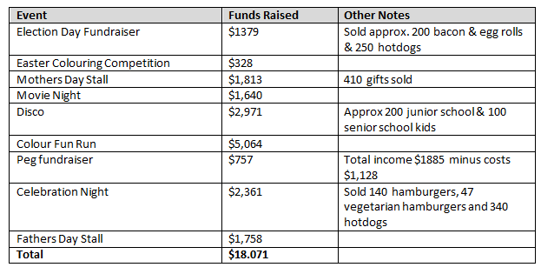

**Playground Committee**

**Busy Bee**

A busy bee was organised by the Playground Committee on Saturday 26th June. It was a big success with materials donated by Bunnings O’Connor and funding from Dr Jags MLA to offset the other materials including the sausage sizzle lunch.

Works included painting the undercoats for the basketball court wall, repainting the hopscotch, four square lines etc around the walkways, timber coating the play equipment in the large playground and kindy/pp playground area, adding some equipment into the kindy/pp play area, including refreshing some of the gardens.

Thanks go to the 38 adults and 27 kids working hard to give the school grounds a refresh. In addition, a big thanks to Rachel King, Deb McFarlane, Julie McCarthy and Sharon Marchenko for organising and lending a big helping hand.

**Kindy/PP Playground Works**

The largest contribution by the committee was to the upgrade to the kindy/pp playground area at a cost of $33,920 plus $1,500 for the design plans. The Playground committee met a number of times throughout the year to obtain initial quotes and designs. Ultimately the funding was allocated to Admin who engaged Programmed to undertake the project management including obtaining quotes, confirming and coordinating the works. Thank you to Rachel King for her tireless work pursuing the playground quotes and design elements. Thank you also to Sharon Marchenko for ultimately taking the lead and ensuring the works were implemented in a timely manner.

The Playground works were conducted 24th November – 9th December. The students are enjoying the nature play elements including the riverbed during this hotter weather.

The bike path, which is partially funded through a Your Move Grant, is being constructed this week as a separate piece of work to improve the kindy/pp playground area.

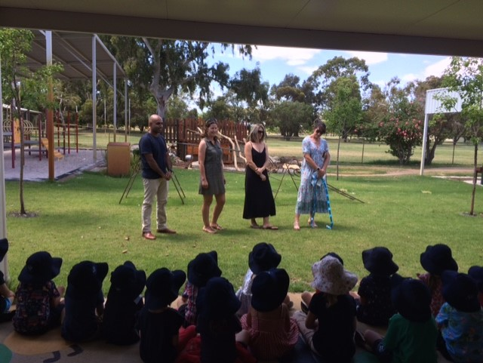 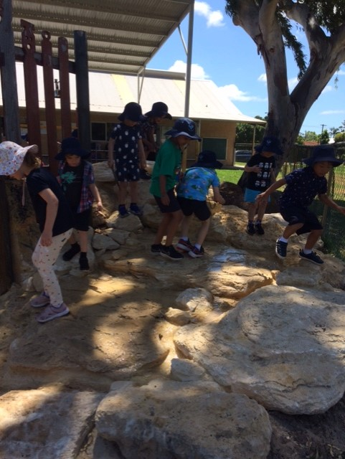

**Ship Shape Project**

$19,550 was received through the City of Melville Project Robin Hood grant process. Due to other priorities for administration, and a purchase limit for contractors any work on this project implementation is being delayed until September 2022, which will leave 10 months to plan, engage, implement and complete any works.

During the year the school collected enough Your Move Points to obtain a grant for the bike path in the Kindy/PP area. We have also earnt 556 points to offset some Constable Care bike training costs (Two classes attending requires 738 points excluding bus costs). Points are earnt through conducting hands up surveys, carrying out sustainable transport initiatives in the school and reporting on them on the website.

In addition, the President, Nicky Stott, Admin and some other parents, monitored traffic activities speaking to parents that weren’t obeying the traffic management practices, and sent messages via Connect.

In the absence of a traffic committee, it is hoped that the Year 6 Sustainability Leaders, and the allocation of Danni DiFonzo to sustainability activities, will take the lead on promoting sustainable transport. Issues will continue to be raised at P&C General Meetings on an ad-hoc basis if required.

